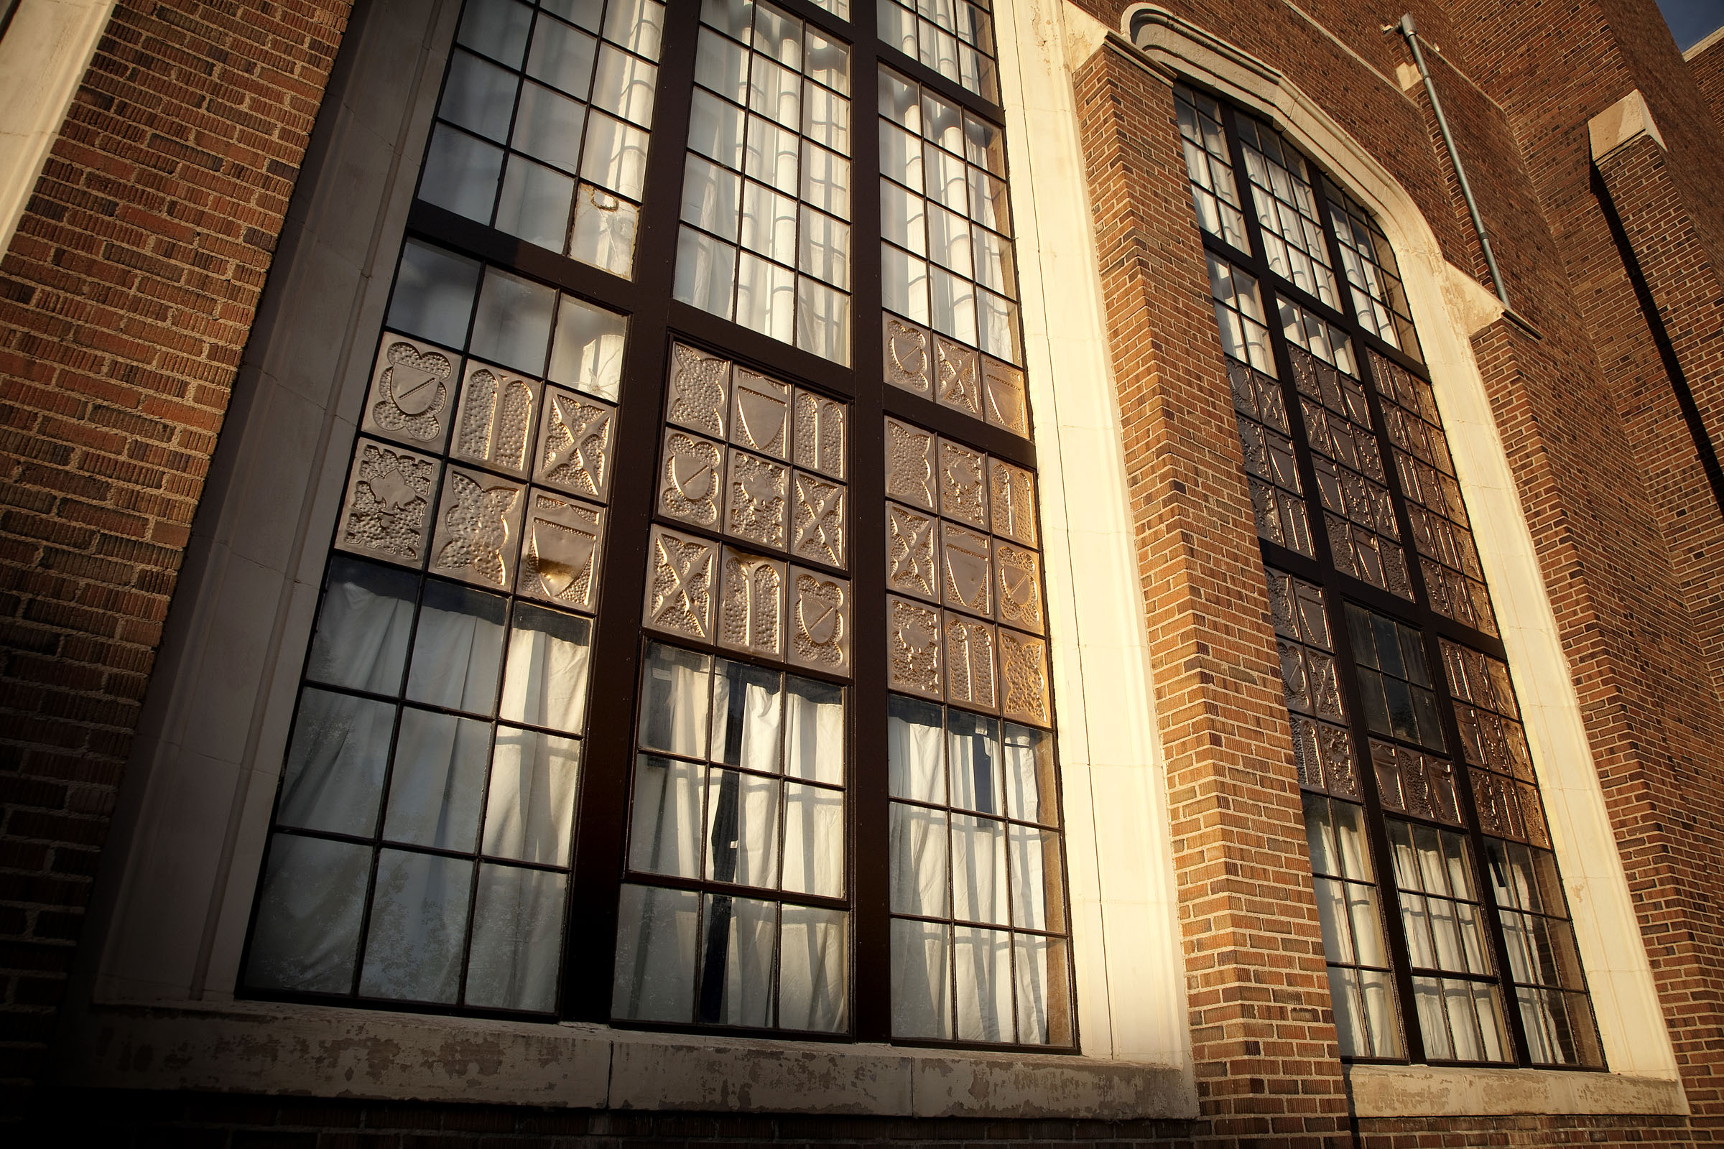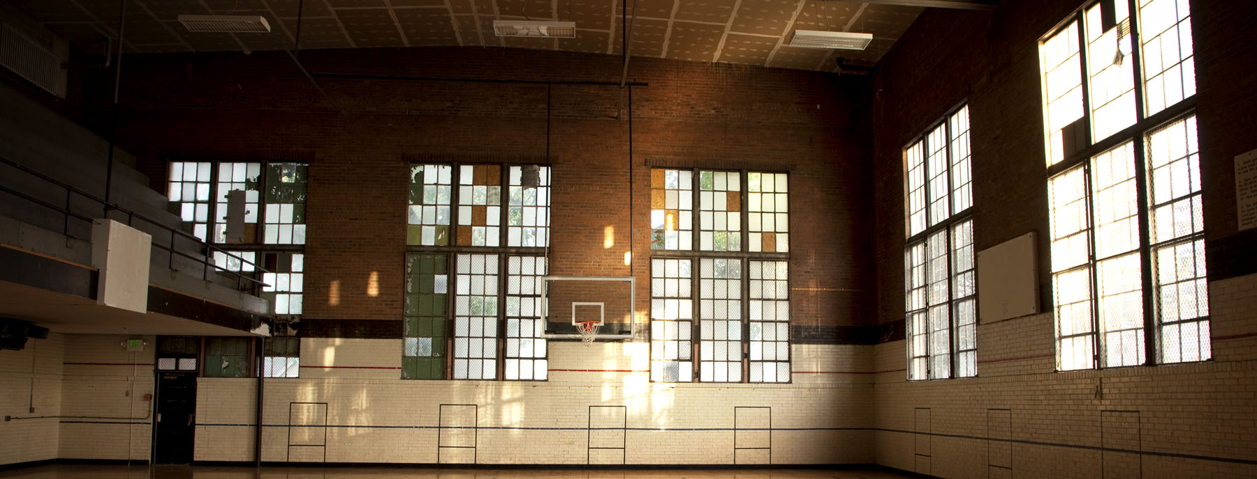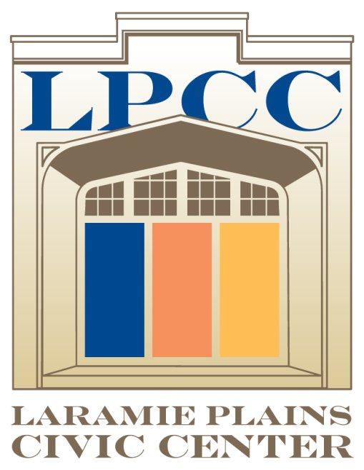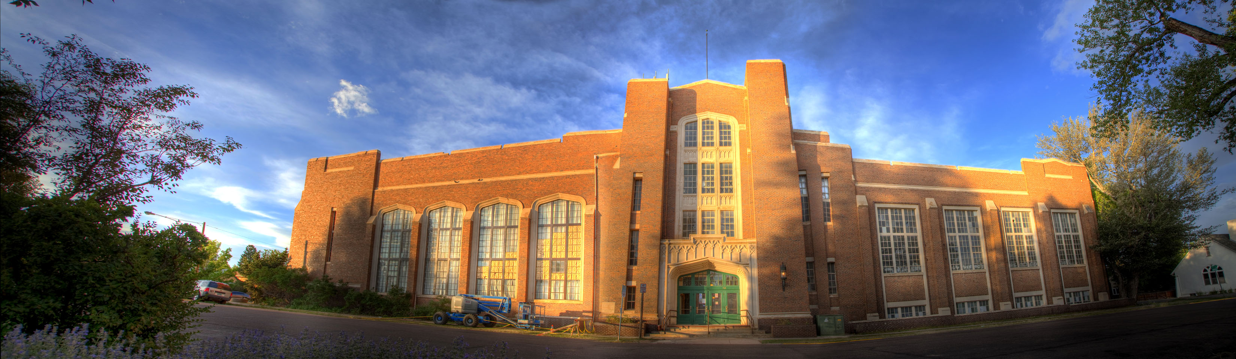

Be our fan on Facebook and follow us on Twitter

All donors will receive recognition in the Laramie Plains Civic Center as well as acknowledgement on the LPCC social media pages and on the official website of the LPCC.

Feel free to deduct your donation from your taxes.

EIN: 90-0730751

To donate please visit [www.LPCCWY.org](http://www.LPCCWY.org)  
 or call the LPCC at 307.745.8000

Laramie Plains Civic Center Foundation

710 East Garfield Street Suite 116  
Laramie, WY 82070

www.LPCCWY.org

### Laramie Plains Civic Center Foundation

### 307.745.8000

#### Serving the Laramie community for 134 years, the LPCC is one of the community’s most historic buildings.

Originally built in 1878 as the East Side School, the LPCC is the oldest school building in the state. Functioning as both Laramie’s high school and junior high, the building served as an educational institution for 100 years before finally becoming the Laramie Plains Civic Center in 1979. Placed on the National Register of Historic Places in 1981, the LPCC is truly one of the community’s most historic treasures!

🙞 🙜

INTRODUCING:

***ADOPT***

***-A-***

***WINDOW***

## How To Donate

# History

Donation Levels

Freshmen: $1 - $499

Sophomore: $500 - $999

Junior: $1,000 - $$2,999

Senior: $3,000 - $9,999

Corporate: $10,000 and up

Community Recognition

All donors will receive permanent recognition in the LPCC as well as recognition during performances at the Gryphon Theatre for one year.

Recognition varies per donation level.

How To Donate

First Interstate Bank

LPCC office

www.LPCCWY.org

Cash, Check, Master Card, Visa

Remember us in your estate planning

Contact Us

Laramie Plains Civic Center Foundation

307-745-8000

710 Garfield Street, Suite 116

www.LPCCWY.org

## Donating

# Help Improve *Your* Laramie Plains Civic Center

The Laramie Plains Civic Center (LPCC) is a multi-use building that continues to grow and adapt to the needs of the Laramie community as a space for education, recreation, retail, entertainment, and workplace. Currently operating at maximum capacity, the facilities of the LPCC provide an otherwise unmet need of the community members to gather, teach, and explore new possibilities for a diverse demographic.

The Laramie Plains Civic Center Foundation was established to assist and support the restoration and refurbishment of the LPCC. It is through private donations that the LPCC Foundation is able to fund these necessary renewals.

With current renovations underway, and plans to further the restoration of the building, the LPCC is striving to maintain the cultural and historical integrity of the building while also providing a retail, entertainment and workplace for the Laramie community.

A historic landmark for 134 years, the LPCC is currently in the process of replacing and refurbishing over 500 windows. Looking first and foremost to increase tenant comfort, the purpose of the window renovations is also to increase the aesthetic appeal of such a historic building, while at the same time increasing energy efficiency.

The window refurbishment is just one part of the LPCC’s 10-year plan. With previous renovations such as theatre upgrades, office remodels, and restoration of the South gym, the window refurbishment will only improve the LPCC and the Laramie community.

The LPCC funds these projects primarily via grants and private donations. We look to the Laramie community to help restore a building that has done so much for this historic city.

Be a part of history and adopt a window at the LPCC today!